Scaffolds and Rope Descent Systems Training Material and Comprehensive Quiz

- Policy
  - The management is committed to the compliance and implementation of the Fall Protection Program and the assignment of responsibilities and the assurance of employee compliance.
  - The management ensures that a person or persons with authority and responsibility is designated for implementing the program.
  - A system is in place to ensure that employees comply with safe and healthy work practices.
  - Communication with employees in a form readily understandable by all affected employees on matters relating to occupational safety and health is established, including provisions designed to encourage employees to inform the employer of hazards at the worksite without fear of reprisal.
  - Procedures to identify and evaluate workplace hazards including scheduled periodic inspections to identify unsafe conditions and work practices are established.
  - Inspections are made to identify and evaluate hazards.
  - A procedure to investigate occupational injury or occupational illness is established.
  - Correcting unsafe or unhealthy conditions, work practices, and work procedures are established in a timely manner based on the severity.
  - The management provides training and instruction for this program.
  - Employees are allowed access with the right and opportunity to examine and receive a copy of the program.
  - Inspection and assessment of the program are conducted on a regular basis and are properly documented.
  - Record keeping and documentation are established in implementing and maintaining the program.

- Procedure
  - Scaffolds
    - A scaffold is any temporary elevated work platform and its supporting structures (including points of anchorage) used for supporting people or materials or both.
    - All fabricated or conventional supported scaffolds exceeding 6 meters in height or a working load of 150 kg/m², structural steel should be used, shall be designed and inspected by the structural engineer, and approved by the appropriate authority.
    - All scaffold inspections must be conducted by a person who underwent standard scaffold training and assessment prescribed by OSHA.
  - Types of Scaffolds
    - Supported scaffolds
      - Consists of one or more platforms supported by outrigger beams, brackets, poles, legs, uprights, posts, frames, or any rigid support.
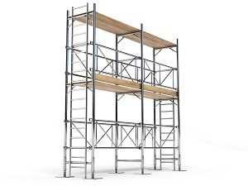
    - Suspended scaffolds
      - Platforms suspended by ropes or other non-rigid means from an overhead structure.
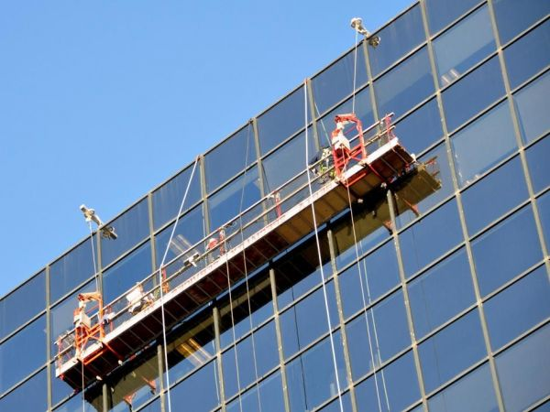
  - Hazards and Accidents Associated with Scaffolds
    - Hazards
      - According to a study made in June 2020 entitled “Causes of Accidents Involving Scaffolding at Construction Sites”, the following are the usual accidents involving scaffolding:
Frequency (%) | Usual Accidents
23 | Result of construction deficiencies
18 | Electrocutions
14 | While climbing
10 | Falling objects
10 | Structural failure
10 | Falls while working on the platform
8 | While assembling/disassembling the scaffolding

    - Root Cause
      - Unguarded or improperly guarded scaffolds may cause workers to fall from height.
      - The absence of appropriate guardrails and toe boards can allow tools and materials to fall and can hurt workers on the lower level.
      - Improperly installed and wrong dismantling procedures can cause a scaffold to collapse in a manner that could cause injury or death.
      - Working close to energized electrical power lines can cause electrocution of the scaffolders.
  - Control Measures
    - Inspection and Tagging
      - Ensure scaffolds are erected, moved, dismantled, or altered under the supervision of a competent person.
      - Make sure a competent person inspects the scaffolding and, at designated intervals, repeat the inspection.
      - Ensure a competent person inspects rigging on suspension scaffolds before each shift and after any occurrence that could affect structural integrity.
      - Check the synthetic and natural rope used in suspension scaffolding is protected from heat-producing sources.
      - Always make sure that scaffolds are always at least 10 feet from electric power lines.
      - Equip scaffolds with guardrails, mid rails, and toe boards as required.
      - Make sure that scaffolds are not moved horizontally while workers are on them unless they are designed to be mobile, and workers have been trained in the proper procedures.
    - Precautions when Using Scaffolds
      - Ensure that employees are taking protection while working near overhead power lines.
      - Access scaffolds by using ladders and stairwells. Do not use cross-bracing.
      - Provide employees with a full body harness when working at a height of more than 6 meters.
      - Make sure scaffolds are sound, rigid, and sufficient to carry their weight plus four times the maximum intended load.
      - Ensure scaffolds are erected on solid footing.
      - Do not support scaffolds or planks with unstable objects.
      - Never use scaffold accessories such as braces, brackets, screw legs, or ladders that are damaged or weakened.
      - Use tightly plank scaffold platforms with scaffold plank grade material or equivalent. Ensure all scaffolds are fully planked.
      - Do not allow employees to work on scaffolds when covered with slippery materials.
      - Do not permit work in bad weather or strong winds.
    - Safe Work Practices
      - Make sure workers are properly trained.
      - Operate elevating work platforms according to the manufacturer’s specifications.
      - Never override hydraulic, mechanical, or electrical safety devices.
      - Never move the equipment with workers in an elevated platform unless permitted by the manufacturer.
      - Do not allow workers to position themselves between overhead hazards such as joints and beams, and the rails of the scaffold.
      - Maintain a minimum clearance of at least 10 feet away from the nearest energized overhead lines.
      - Use a body harness or restraining belt with a lanyard attached to the scaffold to
      - Use outriggers if provided.
      - Do not exceed the limits of the equipment as specified by the manufacturer.
  - Rope Descent Systems
    - A Rope Descent System is a non-motorized system that uses gravity, with the worker controlling their rate of descent to access the interior and exterior facade of a building.
      - The system's friction device also allows workers to stop the descent and remain suspended at any location along their rope to perform their work.
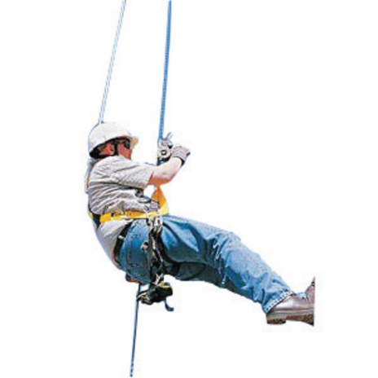
    - Before any rope descent system is used, the building owner informs the employer, in writing that the building owner has identified, tested, certified, and maintained each anchorage so it is capable of supporting at least 5,000 pounds (2,268 kg), in any direction, for each employee attached;
      - The information must be based on an annual inspection by a qualified person and certification of each anchorage by a qualified person, as necessary, and at least every 10 years;
    - The employer ensures that no employee uses any anchorage before the employer has obtained written information from the building owner that each anchorage meets the requirements of the paragraph above;
      - The employer keeps the information for the duration of the job;
    - Do not use a rope descent system for heights greater than 300 feet (91 m) above grade unless the employer demonstrates that it is not feasible to access such heights by any other means or that those means pose a greater hazard than using a rope descent system;
    - Ensure to use of the rope descent system by instructions, warnings, and design limitations set by the manufacturer or under the direction of a qualified person;
    - Make sure each employee who uses the rope descent system is trained in accordance with § 1910.30;
    - Inspect the rope descent system at the start of each work shift that it is to be used. The employer ensures that damaged or defective equipment is removed from service immediately and replaced;
    - Provide the rope descent system with proper rigging, including anchorages and tiebacks, with particular emphasis on providing tiebacks when counterweights, cornice hooks, or similar non-permanent anchorages are used;
    - Use separate, independent personal fall arrest system for each employee that meets the requirements of subpart I of this part;
    - All components of each rope descent system, except seat boards, are capable of sustaining a minimum rated load of 5,000 pounds (22.2 kN). Ensure seat boards are capable of supporting a live load of 300 pounds (136 kg);
    - Prompt rescue of each employee is provided in the event of a fall;
    - Ensure the ropes of each rope descent system are effectively padded or otherwise protected, where they can contact edges of the building, anchorage, obstructions, or other surfaces, to prevent them from being cut or weakened;
    - Provide stabilization at the specific work location when descents are greater than 130 feet (39.6 m);
    - Prohibit employees from using the rope descent system during hazardous weather conditions, such as storms or gusty or excessive wind, are present.
    - Secure equipment, such as tools, squeegees, or buckets by a tool lanyard or similar method to prevent it from falling; and
    - Protect ropes of each rope descent system from exposure to open flames, hot work, corrosive chemicals, and other destructive conditions.

- Responsibility
  - Health Committee
    - The members of the committee are responsible for helping implement the safety measures for scaffolds and rope descent systems. Their responsibilities include:
      - Meet not less than quarterly;
      - Prepare records of health and safety discussions;
      - Review inspection results;
      - Review accidents;
      - Review hazardous conditions brought upon by committee members; and
      - Submit recommendations to the management regarding safety and health.
  - Management
    - Check purchase orders of items necessary to implement the program.
    - Record delivery receipts.
    - Document the quantity and quality of each incoming delivery.
    - Provide the necessary support to the health committee such as a sufficient budget for the program maintenance.
  - Quality Assurance
    - Help analyze or audit the results of safety inspections.
    - Check the implementation of all corrective actions taken to improve health and safety in the workplace.
    - Report health and safety hazards that may affect the quality or compliance of raw materials, ingredients, or finished products.
  - HR Department
    - Facilitate the hiring of qualified personnel needed to maintain the safety procedures for using scaffolds and rope descent systems.
    - Organize trainings and seminars that will bolster the knowledge and skills of all employees related to safety and health procedures.
    - Ensure that all employees follow the program and its regulations which includes conducting the necessary disciplinary actions to violators and commendation to outstanding employees.

- Corrective Action
  - Hazards that are discovered must be addressed in a timely manner depending on its level of risk.
  - Root cause analysis must be done to evaluate the hazards so that an effective control measure may be implemented.
  - In the event that a hazard cannot be corrected immediately without risking employee safety, evacuation procedures must be initiated.
  - Employees that are tasked with removing or controlling discovered hazards must have the necessary training and personnel protective equipment.

- Review - Quality
  - Review of the criteria for developing and approving rules and regulations.
  - Inspect workplace and its potential hazards and unsafe practices.
  - Review of records pertaining to the program.
  - Interview of employees regarding workplace safety.

- History
Revision No.: | Revision Date: | Description of Change: | Originator / Author Name: | Title / Department:
0 | 20210104 | Original | Arnel Ryan | PCQI/Compliance
1 | 20241005 | - Changed email from services@consultareinc.com to rfp@consultareinc.com | Arnel Ryan | PCQI/Compliance

Requirements:
- The trainee has read or received a verbal translation of all or part of the policy, procedure, method, and/or SOP for which they are being trained.
- The trainee has demonstrated the task they are to perform or the procedure for which they are being trained as required.
- The trainee has demonstrated the ability to perform the task with acceptable proficiency and minimal supervision.

TRAINEE (Print Name): | TRAINEE (Signature): | Date: | Department:
Trainer / Supervisor (Print Name): | Trainer (Signature): | Date: | Department:

UPON COMPLETION – EMAIL TO rfp@consultareinc.com

NAME (Print): | Date:

Scaffolds and Rope Descent Systems Comprehension Quiz

Direction: Choose the best answer and encircle the letter.

- A temporary elevated work platform that is used for supporting people and materials.
- Scaffold
- Rope Descent System
- Ladder

- Consists of one or more platforms supported by outrigger beams, brackets, poles, legs, or any rigid support.
- Supported Scaffold
- Suspended Scaffold
- Air Lifts

- Who is responsible for providing the necessary support to the health committee such as a sufficient budget for the program maintenance?
- HR Department
- Employee
- Management

- What is the minimum load for rope descent systems?
- 4,000 pounds
- 5,000 pounds
- 6,000 pounds

- What is the most common cause of scaffold accidents?
- Electrocution
- Falling Objects
- Construction deficiencies

UPON COMPLETION – EMAIL TO rfp@consultareinc.com

